ERASMUS+ EXCHANGE PROGRAMME BETWEEN
University of Zagreb, Croatia & Ural Federal University
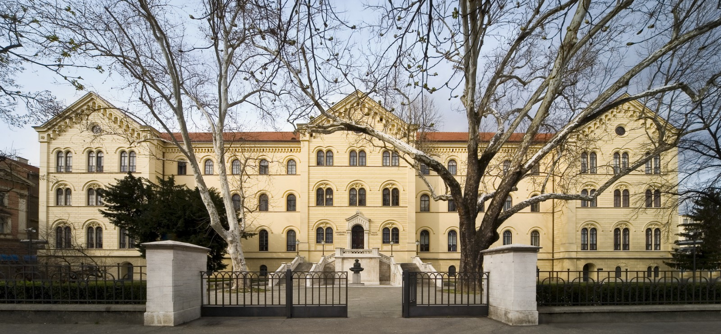

WHAT IS ERASMUS+?
Erasmus+ is a European Union programme for education, training, youth and sport. In specific, it enables student exchange among EU universities and offers exchange opportunities between Europe and non-European partner universities.
WHERE CAN YOU GO ON EXCHANGE AND HOW LONG?
University of Zagreb, Croatia - http://www.unizg.hr/
WHEN?
1st/winter semester 2017/2018 – 5 months exchange
(planned period: end of September 2016 – end of February 2017)

WHO CAN APPLY?
UNIZG STUDY PROGRAMMES AVAILABLE FOR EXCHANGE STUDENTS
FROM | TO | Subject area code  *  [ISCED] | Subject area name  * | Study cycle  [1st , 2nd or 3rd] | Number of student mobility periods
 |  |  |  |  | Student Mobility for Studies  [total number of months of the study periods or average duration*] | Faculty University of Zagreb
Ural Federal University | HR ZAGREB 01 | 0312; 0320 | Political Science and Civics; Journalism and reporting | 1st , 2nd | 5 months  (1 student x 5 months) | Faculty of political science
 |  | 0410; 0488; | Business, administration and law, interdisciplinary programmes; Business and administration | 1st , 2nd | 5 months  (1 student x 5 months) | Faculty of economics and business
 |  | 0314; 0320; 0222 | Sociology and cultural studies; Journalism and information; History | 1st , 2nd | 5 months  (1 student x 5 months) | Center for Studies
 |  | 0788; 0711; 0531 | Engineering, manufacturing and construction, inter-disciplinary programmes; Chemical engineering and processes; Chemistry | 1st , 2nd | 5 months  (1 student x 5 months) | Faculty of Chemical Engineering  Faculty of machinery and naval architecture
FINANCIAL SUPPORT FOR ERASMUS+ EXCHANGE STUDENTS
Individual support  (monthly scholarship) | Travel costs
800 EUR per month | 1 return plane ticket (bought by the UNIZG)
*Exchange students will be required to take out travel/medical insurance to cover their stay in Croatia on their own.
HOW TO APPLY FOR EXCHANGE AT THE UNIVERSITY OF ZAGREB
Interested students need to be nominated by their home university of exchange with the University of Zagreb (please contact your home university coordinator). After the nomination, students will receive information about the application procedure from the UNIZG.
Application documents for exchange:
- Curriculum Vitae (English),
- the Learning Agreement containing your planned course units at the University of Zagreb
- Official Grade Transcript from home university (English),
- Certificate of Enrolment from home university(English),
- Copy of passport,
- Proof of English level - B2 (intermediate) level according to the Common European Reference for Languages (all kinds of language certificates are accepted)
Students will be able to participate in courses/study programmes given in English (and Croatian).
Graduate & PhD students that intend to do research for their final thesis need to send a short thesis/research outline so a mentor at UNIZG can be assigned prior to the start of mobility.
Students are guaranteed accommodation in one of three student halls of residence if the apply for it.
More information can also be required for the UNIZG coordinator:
Zeljka Pitner (Ms)
International Relations Office, University of Zagreb
@: zeljka.pitner@unizg.hr
Trg marsala Tita 14, HR-10000 Zagreb, Croatia
Phone: 00385 1 46 98 105

APPLICATION DEADLINE AT UNIZG: 10 May 2017.
MORE INFORMATION FOR INTERESTED STUDENTS
Estimated monthly living expenses
Student living expenses will vary according to individual needs and the ability to budget and manage finances. In particular if you want to travel a lot and take full advantage of the available cultural and social opportunities, expenses will be higher. The estimates below are therefore a general guide.
Food 1.000HRK (132€) /month
Rented private room/shared apartment and Utilities
(water, electricity, heating, phone) 1.500HRK (200€) /month
Transportation 100HRK (13€) / month
Books 400HRK (53€) / month
Miscellaneous 800 HRK (105€) / month
TOTAL: 3.800 HRK (132€) /month (approx. 500-600€/month)

UNIVERSITY OF ZAGREB – PROFILE
The University of Zagreb, founded in 1669, is the oldest university in Croatia and particularly rich in tradition. As a comprehensive public Central European university, it offers education and research in all scientific fields and a broad spectrum of courses at all study levels, from undergraduate to postgraduate.
With 29 Faculties, 3 Art Academies and the University Centre for Croatian Studies it is the flagship educational institution in the country, a place where more than 7,500 employees and 77,000 students develop knowledge and acquire skills.
The University excels not only in teaching, but also in research, contributing with over 40% to the annual research output in Croatia.
SHORT COUNTRY INFO: CROATIA - COUNTRY OF THOUSAND ISLANDS
Geographically situated at the crossroads of the Pannonian Plain, the Balkans and the Adriatic Sea, Croatia is a country of great natural diversity, a thousand-year-old historical heritage and a pleasant climate. A perfect mixture of Central Europe and Mediterranean culture, Croatia is unique by its 1,185 islands along the coast.
At the crossroads between the East and the West, Croatia has always been a melting pot of different nations, religions and languages. In the last decades the country has been through dramatic ideological and political changes, having managed to declare independence from the six-republic state of Yugoslavia after the Homeland war.
Croatia joined the European Union in July 2013, and became the youngest, i.e. 28th EU member state.
SHORT CITY INFO – ZAGREB
Zagreb is the capital of Croatia and also the largest city in the country. Situated in the north-west of the country, along the Sava River, it has a population of almost one million inhabitants. It is a vibrant city with beautiful museums, theatres, parks, bars and clubs, open green markets and coffee shops in the streets always filled with crowds engaged in conversation. Zagreb is just a couple of hours away from great resorts and hiking opportunities along the Adriatic coast. The nearby mountain Medvednica, reachable by city public transportation, offers skiing possibilities and hosts the men’s and women’s Skiing World Cup in the winter. In Zagreb, the rich academic, cultural and social resources all become part of the studying experience only a capital city offer.

