Tips for filling in an application form

- Please, note that you should fill in both: online application form and a hard copy (a file attached below).
You should print it, fill in, sign, then scan and upload oh the website with the rest of the documents. Or you can save a completed online application form as PDF, print it, sign, glue a photo, scan and upload.

- While choosing the code of the program (№№ 23.1 & 23.2), please, use the website http://russia-edu.ru/.

Choose:
- Level of education
- Scientific sphere
- Enlarged group of educational programs
- Educational program

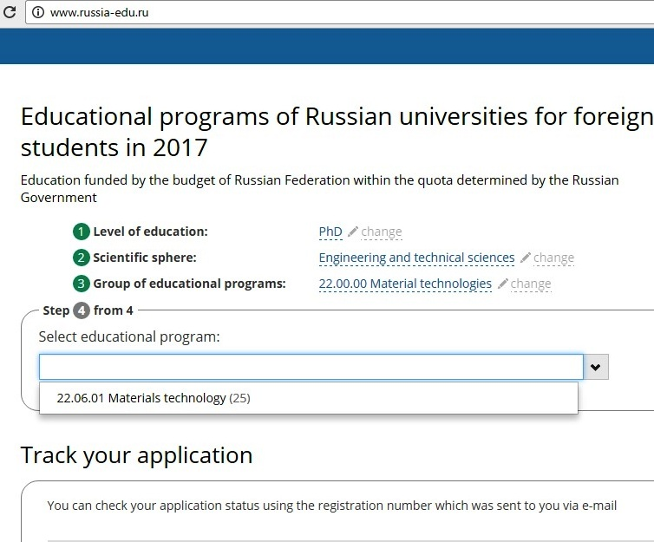

- In the application form you should mention the code: __.06.01

- Please, check the chosen code with your prospective supervisor!

